**NAAN MUTHALVAN**

**INTRODUCTION:**

**Automatic Zoom**

11mproving graphic designes with Canva

Our project title is Graphic Designing with Canva in this course we have learned to create empathy map,brainstroming map and designing certificate by using Canva

An Empathy map is a tooll that helps you understand and empathize with your users or customers.our team's empathy map topic is about the buying a new table person's feeling & sense our team discussed about the title "buying a new table we gathered the valid ideas from the team members and created the

empathy map. Brainstorming is a problem-solving activity where students build on or develop higher order thinking skills and also it encourages creative thoughts our team's brainstroming topic is 'loan' by using brainstroming method our team detaily collect the information about the topic 'loan' we also analyze credit scores,income,employment history,debt-to-income retios,and other financial

factors to determine a individul's creditworthiness.AI can be used to detect

fraudulent loan applications by analyzing data patterns and identifying anomalies.

**Purpose**

Canva is an online design tool that offers users the opportunity to create professional looking posters slideshows

images, event flyersresumes,cards,certificates,infographics,and other media the tool allows studends to design visuals to show case their knowledge in unque ways

PROBLEM DEFINITION & DESING THINKING

**EMPATHY MAP**

We discuss our group to collect the ideas create the project the empathy map

Emaily **B** to our

Group members dicussel

Say-I want something reliable.

Thinks-what else am I missing.

Feels-Exited.

Does-More search.

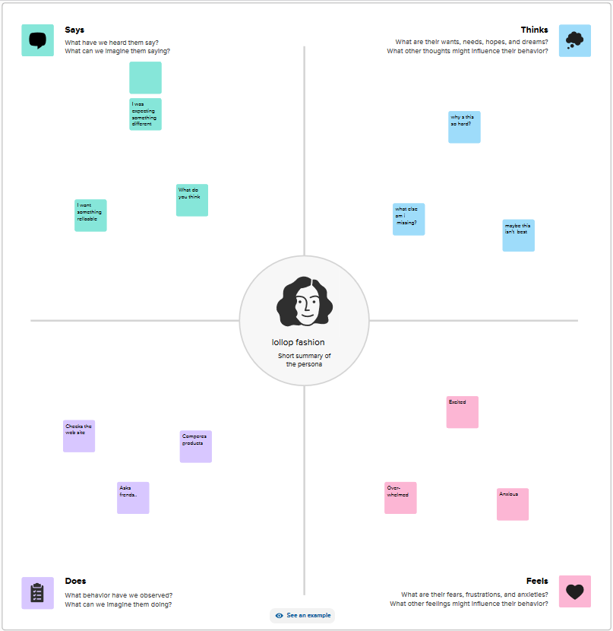

**Ideation & Brainstorman**

We discuss our group to ollect the ideas create the project the brainstorming map

Group members dicussel

Say-I want something reliable.

Thinks-what else am I missing.

Feels-Exited.

Does-More search.

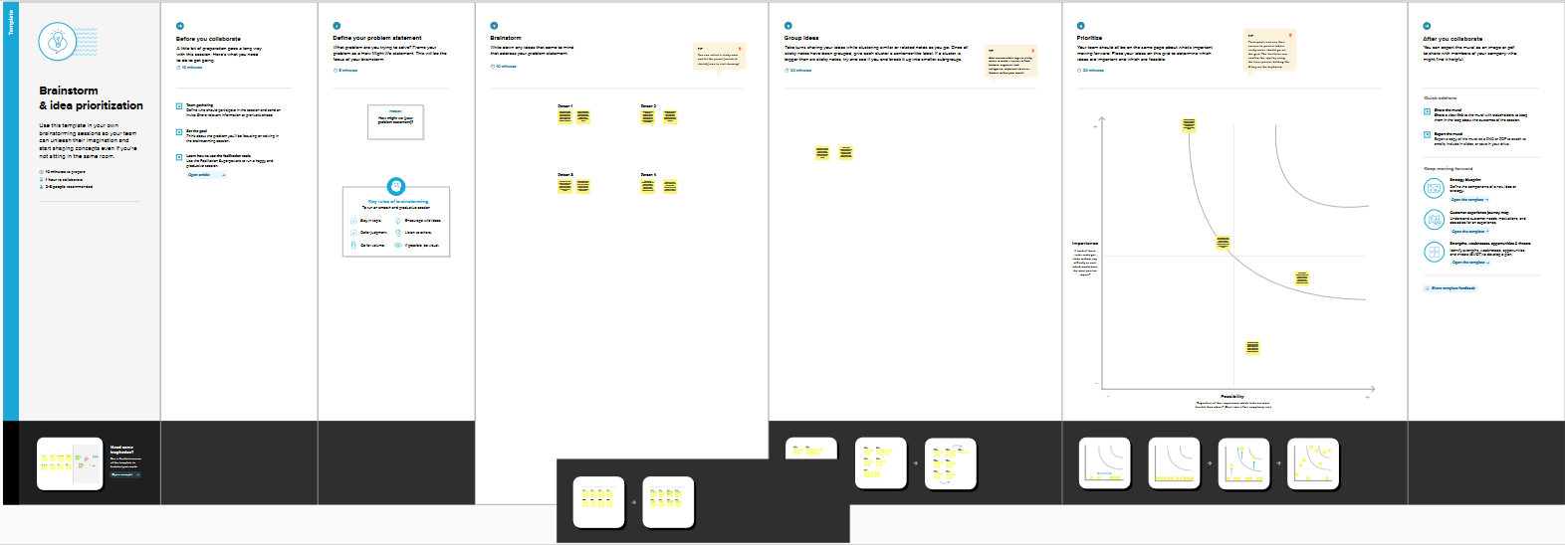

**Project management**

The planning and organizing of a ompany's resources to move a speific tesk, event, or duty toward completion

Human capital

We need investement in human capital to produce more human capit! out of human

resources

Team Building

Most organization are trying to develop a spirit of teamwork

Improve

Aim ought to clear: your words should be clear, brief, and direct

Maintain eye contact: Facial expresions mirror your felings and how you're feeling

right now.

**RESULT :**



**ADVATAGES & DISADVATAGES**

**Advatages**

Student presentation and project and projects instanttly created in Canva in Canva. Being able to create simple comperhensive diagrams and throw ideas down in a virtual, collaorative space. The program will identify students talent and provide traning ultimately better caarreer

**Disadvatage**

Limitated number of free teplets

Export setting are limited

Thedisadvantage of pre-fabricated in mural

Netwok error to upload the lithub

**APPLICATIONS**

Canva is an online design tool that offers uaers the opportunting to create profesionalnlooking posters, slideshows, images, eventlyers, resumes, carde, certificates, inforgraphic, and other media .Our team designed invitation by using Canva.

**CONCLUSION**

Thisthree step process facilitates a holistic approach to understanding, ideation, and exeution Empathy mapping informs brainstoring sesion, and the insights gathused sever as a foundation for creting meaning ful Canva projects. By integrating these elements, individuals and organigations can reat impact ful. Empathetic solutions that adderss real.

Worls problems and connec with their intended audience on a deeper level. ADVATAGES & DISADVATAGES Advatages Student presentation and project and projects instanttly created in Canva in Canva. Being able to create simple comperhensive diagrams and throw ideas down in a virtual, collaorative space. The program will identify students talent and provide traning ultimately better caarreer Disadvatages Limitated number of free teplets Export setting are limited Thedisadvantage of pre-fabricated in mural Netwok error to upload the lithub APPLICATIONS Canva is an online design tool that offers uaers the opportunting to create profesionainlooking posters, slideshows, images, eventlyers, resumes, carde, certificates, inforgraphic, and other media Our team designed invitation by using Canva.

CONCLUSION Thisthree step process facilitates a holistic approach to understanding, ideation, and exeution Empathy mapping informs brainstoring sesion, and the insights gathused sever as a foundation for creting meaning ful Canva projects. By integrating these elements, individuals and organigations can reat impact ful. Empathetic solutions that adderss real. Worls problems and connec with their intended audience on a deeper level.